*Bounty Punk*

Genre - Action, Shooting

Age group – 16+

**Overview**

Bounty punk is a Top down shooter game set in future cyberpunk era where you have to take up a bounty and kill them in exchange for cash.

**Look and feel**

The game will be set in cyberpunk era and the art style will be voxel art.

**Gameplay Overview**

The player will have to select a bounty after selecting a bounty the player will be spawned and the level where the bounty is located, the player will have to clear the enemies to get to the main bounty, the boss will have unique abilities

**Levels**

**Tutorial Level and Base** – our base will be our home where we train and we have to select bounties at our home computer and is also the tutorial level.

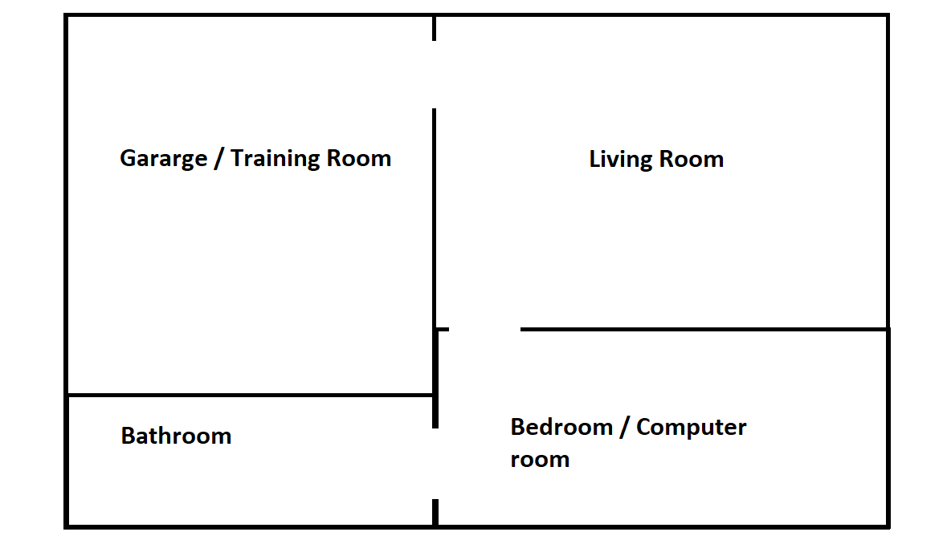

1. Player will start in the living room once the game has been launched here the player will be prompted to press WASD keys for a moving tutorial and to press E key to interact with doors to open them to explore the house or base and player will go to garage.
2. In the garage the player will get combat training or tutorial on how to fight the enemies, the player will be prompted to hold RMB (Right Mouse Button) to aim and while aiming press LMB (Left Mouse Button) to shoot. After the training tutorial is complete the player will have to go to the bedroom.
3. In the bedroom the player will be prompted to press E key and interact with the computer and on the computer the player will have to select the available bounty and according to level selected the next level will load. After game over the player will be spawned in the bedroom.